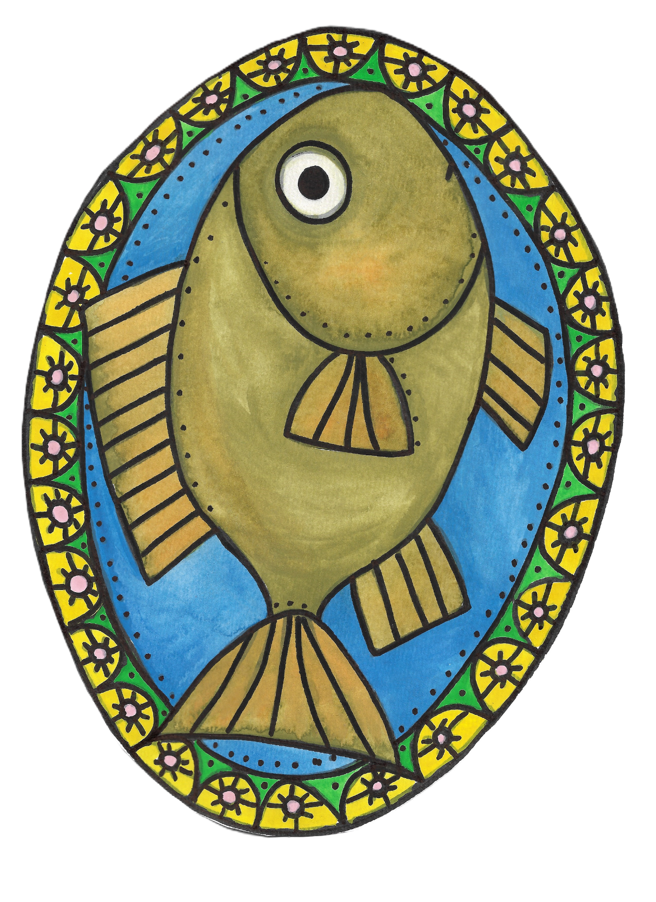
Fish Dish

By Lerin Freyou

Fish Dish
By Lerin Freyou

FISH DISH
Copyright © 2025 LERIN FREYOU. All rights reserved.
Published by LERIN FREYOU
ISBN: 979-8-9932127-5-3

If you ever see a fish in a dish

know that it was not their wish.

Fish usually wish for something more
fun-ish.
Like to find a sunken treasure.

Or to swim longer…just measure.

Or to grow legs so they can run.

Or go tan in the sun.

Okay maybe not tan in the sun.

They would probably dry out.

Like a fishy raisin.

But they could kick a ball if they had legs.

They could also wish for arms.

They could wear a sweater if they had arms.
Or a muscle shirt.

Or a turtle neck shirt.

Do fish have necks?

Turtles do. But what about fish?

Necks are funny, but important.

They hold up your head.

But seriously, think about the fish neck thing.

Anyway…
fishes can make a lot of wishes.

But most of them don’t involve dishes.

Maybe checking out a good bait.

Or even finding a mate.

Or they could wish to fly.

That would be fun.

A fish with wings…think about that.

Or a fish with a really tall hat.

What do you think about that?

A fish could make many a wish.

But I’m pretty sure they would never wish
to end up in a dish.

